November, 2025
To Prospective School Board Candidates:
To help you file all of your Campaign Finance Reports and other ballot access documents properly, please note the following important points:
- The Local Campaign Finance Registration Statement (CF-1) should be filed as soon as you have “formed the intent” to run for School Board. If you have formed a committee and are speaking publicly about your campaign, this is the time to file this form.

- A Declaration of Candidacy (EL-162sd) can be filed at any time after the Local Campaign Finance Registration Statement is filed and must be received by the deadline. The way you state your name on the Declaration of Candidacy form will be the same way it is written on the ballot. Please take care that it all matches.

- The deadline for filing both forms is Tuesday, January 6, 2026. Forms must be received by 5:00 p.m. that day.
The Wisconsin Ethics Commission website: http://ethics.wi.gov, provides additional information and forms: ethics.wi.gov/Pages/Resources/ResourcesOverview.aspx has all of the forms for reports and statements under the campaign finance laws. Please be sure you are using forms for Local Candidates/School District. We have provided most of the forms you will need for your campaign.
Please feel free to contact me if you have questions about election information or paperwork. You may also contact the City Clerk’s office at 364-6680 or the County Clerk’s office at 757-5660 with questions about elections.

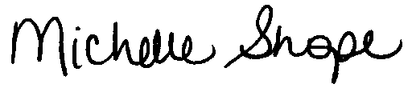
Sincerely,

Michelle Shope, Board Secretary
School District of Beloit
1500 Fourth Street
Beloit, WI 53511
(608) 361-4180
mshope@sdb.k12.wi.us

